Dawson
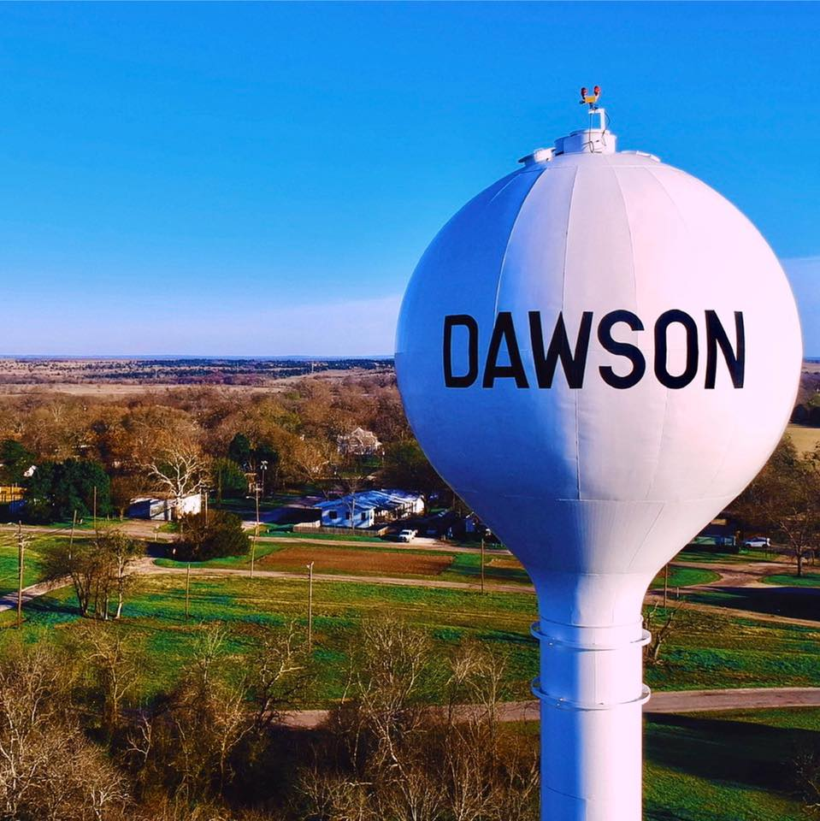
Upcoming events
Dawwg Days of Dawson
July 24, 2021
Kicking off with a pancake breakfast with the voluntary fire department and ending with a street dance.

City Council Meeting
July 6, 2021
6 PM

Bits & bytes
“Home is where the heart is, and your hometown always has your heart.”-Anonymous
Welcome to Dawson’s first monthly newsletter, where YOUR VOICE matters. This newsletter is being provided to you, free of charge, so we can all keep informed of our Dawson happenings. You can find our newsletter at www.dawsonbitsandbytes.com. We plan to print quarterly newsletters and have monthly newsletters online.
What would you like to see in the next Dawson Bits and Bytes Newsletter? We want to hear from you! The goal of our newsletter is to provide a non-biased form of communication for our citizens, and to bring our citizens together as a community. If you see something or have an idea that you would like to share, please contact us at DawsonBitsandBytes@gmail.com.

History of Dawson
Dawson’s history is a short but exciting one with the first settlers moving to the area in 1847, including Dawson’s future namesake Britton Dawson. Britton Dawson fought in the historic battle of San Jacinto earning his right to the land that he later donated for our city’s founding. It wasn’t until 1908 that our town was incorporated and officially called “Dawson”, only the second town to be established in Navarro County. Through the years Dawson has seen several changes. Watching the railroad come in, seeing businesses flourish, our population soar and then the railroad leaving, causing the decline in market and our population. Then comes the rise of our very own Hollywood star Anjanette Comer and the crash of Braniff Flight 352, and the discovery of Dawson’s own “sea monster”. There is 174 years of amazing history to be shared during Dawson’s Dawwg Days of Dawson, July 24th. Come out and celebrate with us! It will kick off with a Fire Department sponsored pancake breakfast followed by a car show, food and vendors and end with a street dance!

Get to know your City Council
Not many of you get to make it into town and to our monthly City Council meetings, so we wanted to bring the council to you. We encourage everyone to reach out to your councilmembers for any questions, concerns, or suggestions. You can email, call or you can even put a hand-written note through the door at City Hall. Remember to leave your contact information so they can reach you. Your City Council meets monthly on the 1st Tuesday of each month at 6 PM down at City Hall. Come out and support your town and your neighbors!

Honorable Stephen Sanders, Mayor
Stephen.Sanders@cityofdawsontx.com
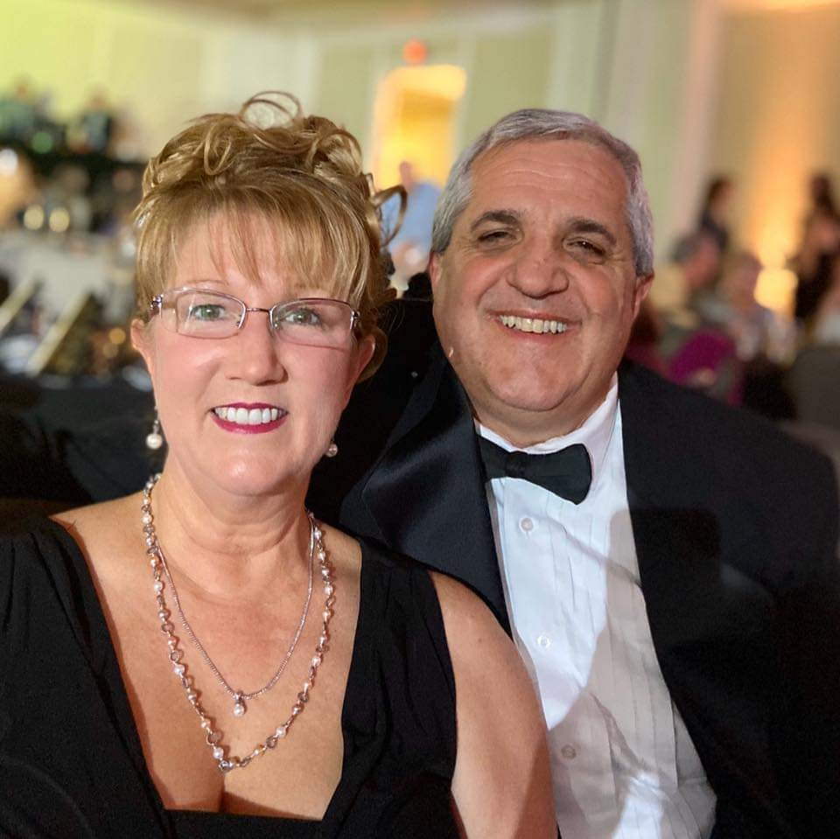
Barbara Leggett-Adler, Mayor Pro Tem
Barbara.Adler@cityofdawsontx.com
Quote: "I was 2 when Mom and Daddy (Robert and Jean Leggett) moved us to Dawson. I have 3 older siblings who also lived here and went to DISD. Dennis was killed the first year we were here and my parents lives here until Daddy died in 1998. Though I moved away for college and my career, Dawson has always been my home. I moved back to build a house with my big sister, Kaye Taylor, after her husband (Tony Taylor) passed away. I felt this is where God was guiding me to work and volunteer. I have a Bachelors and Masters from Texas A&M, am a CPA and I help implement software with internal and external clients at RSM. Fortunately, this allows me to work from home and have a flexible schedule to help with volunteer needs, like Manna From Above Community Food Pantry, Dawson Ex-Students Association, Dawwg Days of Dawson and City of Dawson."

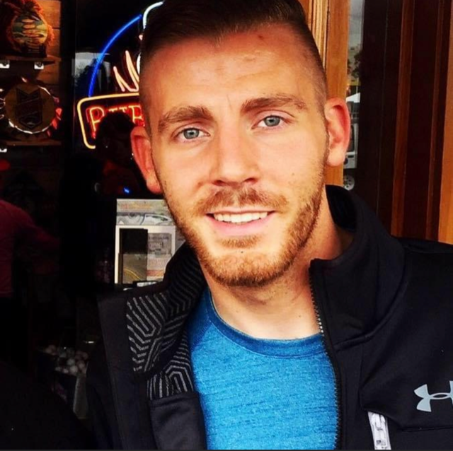
Cameron Shaw, Councilman
Camerson.Shaw@cityofdawsontx.com

Quote: “My name is Cameron Shaw and I am a life-long Dawson resident. My family has a rich heritage that dates back to over 100 years in this city. I graduated from Dawson High School in 2008. Shortly after graduation, I started working as the Technology Director for Dawson ISD and have been there ever since. Many will know my family. My father is Jerry, my mother is Lindy Shaw, and my grandmother Joyce Shaw, who worked at Dawson ISD for 15+ years. My favorite part of living in Dawson is the citizens. There are many genuinely good people in this town. I take much pride in Dawson and want nothing but the best for our community and its citizens. I advocate for a safe, clean, and efficiently ran city that stands out from other communities - from one end of town to the other! Feel free to stop and say hello if you see me around town. I look forward to meeting you! Enjoy Dawson!”
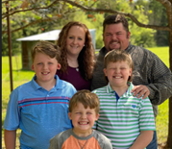
Aaron Hogue, Councilman
Aaron.Hogue@cityofdawsontx.com
Quote: "My name is Aaron Hogue. I Was born in Corsicana, but grew up in Wichita Falls. I moved to Dawson from Biloxi Mississippi in 2007. I met my wife Shelby here in Dawson and now we have 3 boys that all go to school here in Dawson. I currently work for Dawson ISD, and I am Fire Chief for the Dawson VFD. I think this is my 4th term with the City Council. Serving the community is part of what I love to do."

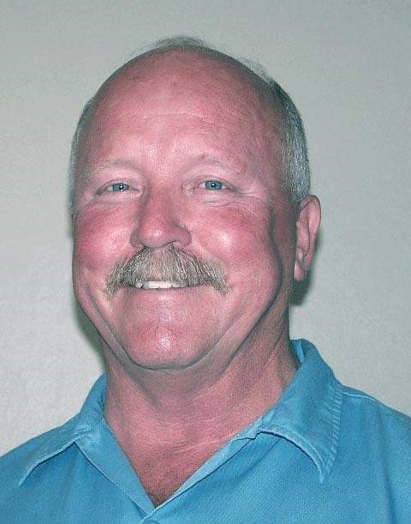
Charles “Chuck” Raines, Councilman
Charles.Raines@cityofdawsontx.com
Quote: "I went to school here, and I have deep roots in Dawson. I love this country and care deeply about its' people!"

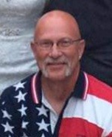
Darrell Stevenson, Councilman
Darrell.Stevenson@cityofdawsontx.com
Quote: “Started attending school at Dawson ISD in 6th grade. Dawson High graduating class of 1973. Jackie Freeland, Phil McCormick, Bryan Prater and Steven Nesmith were some of my classmates. I have lived near or in Dawson most of my life. Currently, I have lived in Dawson for 36 consecutive years.I have been and am currently a City Council member now for 11 years. I give due diligence to my duties and obligations to city business. I have a deep, abiding love for this town and will always have her best interests at heart.

Contact
Our City Hall is located at 112 N Main St Dawson TX 76639
Mailing address is PO Box 400 Dawson TX 76639
Phone (254) 578-1515
Mayor:
Honorable Stephen Sanders
Stephen.Sanders@cityofdawsontx.com

Mayor Pro Tem:
Barbara Leggett-Adler
Barbara.Adler@cityofdawsontx.com
Councilmen:
Darrell Stevenson
Darrell.Stevenson@cityofdawsontx.com
Aaron Hogue
Aaron.Hogue@cityofdawsontx.com
Cameron Shaw
Cameron.shaw@cityofdawsontx.com
Charles “Chuck” Raines
Charles.raines@cityofdawsontx.com
Dawson Police
Zachary Hoffman
903-602-6903

Terry Jacobson
City Secretary
Ronda Franks
Ronda.Franks@cityofdawsontx.com

Let your voice be heard!
Election Results
The much-debated elections on May 1 for 2 (two) City Council Spots and the highly publicized 2.5-million-dollar bond for road and drainage improvements passed by merely 1 vote. YES 1 vote. So, let's get involved and make sure our voices are heard. No matter which way you voted in this election, the results show that every vote counts. We need you! Pick one or more committees then Sign up and get involved! Your voice can lead Dawson in the direction you want to see.
Get involved
Check out some of the committees that are looking for new faces and new voices:
Dawson Strategic Planning Committee
Purpose: To create a vision plan for Dawson at 5, 10 and 15-year intervals. This plan is not to be based upon the fiscal budget. It is a vision plan of where this committee would like to help guide Dawson’s growth and changes in Dawson.
Economic Development Committee
Purpose: To create ideas and strategic plan to grow the business base in the city limits, including businesses who will hire locals and/or add to city funds via sales tax collection.
Dawson City Park Planning Committee
Purpose: To create ideas and plan to make improvements and additions to the Dawson City Park.
Dawson Beautification Committee
Purpose: To create ideas and plan to make improvements and additions to the Dawson City common areas and the overall beautification of Dawson’s neighborhoods.
Remember: If someone is interested in participating in one or more of these committees, they can contact City Hall or email one of the city council members.
“It may take many voices for people to hear the same message.”- Rasheed Ogunlaru

Around the Town Happenings

Whats up and coming in our local churches!
- Navarro Mills Babtist Church
          - VBS June 13-17 from 6-8 PM

- First Babtist Church of Dawson
      - VBS August 2-6 from 6-8 PM

Meet your neighbors
We would like to add in a section to meet our neighbors, share recipes, gardening tips, just anything! Please email or send us a note with your information and what you would like to add! YOU could be spotlighted in our next Newsletter!

Local Business Spotlight
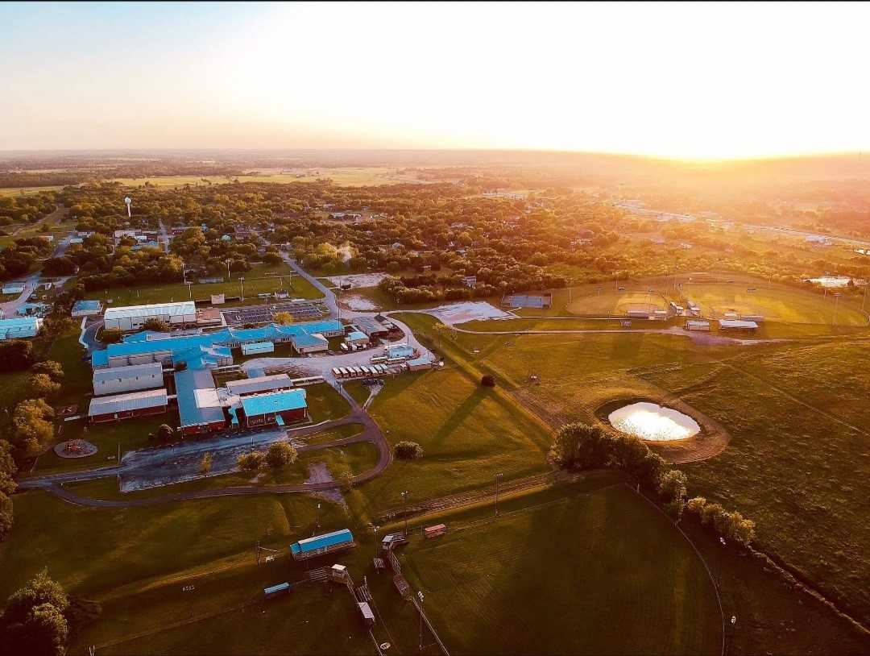

Contact Us
Dawson Bits and Bytes
PO Box 432 Dawson TX 76639
DawsonBitsandBytes@gmail.com
www.dawsonbitsandbytes.com
We would like to support our local businesses. Each month we will spotlight a different local business. We will also highlight any events local businesses have in our town. If you have a local business and would like to be in our Spotlight, please contact us here at Dawson Bits and Bytes.

